**Micro-project Report**

***Balloon Shooting Game***

**1.0 Brief introduction**

Computer graphics has wide importance in real world applications. One of them is animation gaming. Various games are performed using the computer graphics. One of the games is Balloon Shooting. Balloon Shooting game is widely popular in the world. Children have special attraction towards this game. Because the game needs children’s intellectual capacity to win the game. Our project includes simple graphical animated Balloon Shooting game.

The project code consists of various user defined function. This functions are used to create the drawing of bow, creating arrows, releasing arrows, increasing the score, etc., This user defined functions are called from main function to control the flow of the code. The project consists of three level. If the user passes all the levels he/she is declared as winner. Else his loses the game but, his/her score is displayed on screen.

**2.0 Aim of the project**

This micro-project aims were

1. To study the working of Balloon Shooting game.
2. To study the real world applications of computer graphics.
3. To implement the graphics functions.

We have achieved all the aims which were decided at the start of the project. We have completed the project with achieving all the aims at the completion.

**3.0 Course Outcomes Integrated**

1. Describe application of the given display device.
2. Use graphics functions properly.
3. Draw the graphics diagram successfully.
4. Implement line drawing algorithm.

**4.0 Actual procedure followed**

We collected the information of Balloon Shooting game. Then we collected information about computer graphics and the graphics functions. When the collection was over we decided to design overall logic of the project. Logic was decided among us.

After deciding the logic of code we decided the logic of the code. Then we designed code for the program. After designing g the code, we implemented the code and made the program in turbo c7. After making program we debugged some errors in the code and observed the output . Finally we made report.

While creating this project we faced lots of problems. Most of the problems were about the errors. We completed the code by correcting the errors. Finally we completed the project code by debugging all errors. While debugging the errors we learnt various things about that errors.

**5.0 Actual Resources Required**

The resources used during the completion of project are mentioned in the below table:

|  |  |  |  |  |
| --- | --- | --- | --- | --- |
| Sr.no | Name of resources material | Specifications | Quantity | Remarks |
| 1. | Website | [www.sourcecodes.com](http://www.sourcecodes.com) | 1 |  |
| 2. | Turbo C7 | TURBO C++ compatible with Windows 7,8 and vista | 1 |  |
| 3. | Microsoft Word | 2007 version | 1 |  |

**6.0 Outputs of the Micro-project**

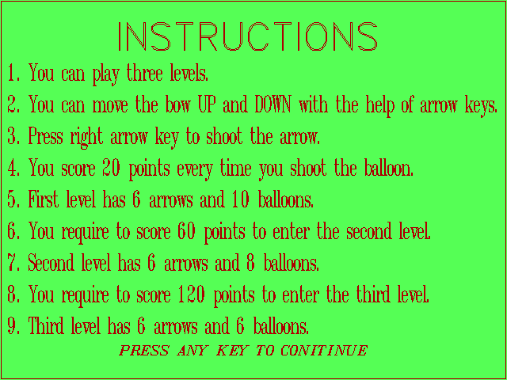

Fig 1: The screenshot is the main screen of the project. These are the instructions to the game

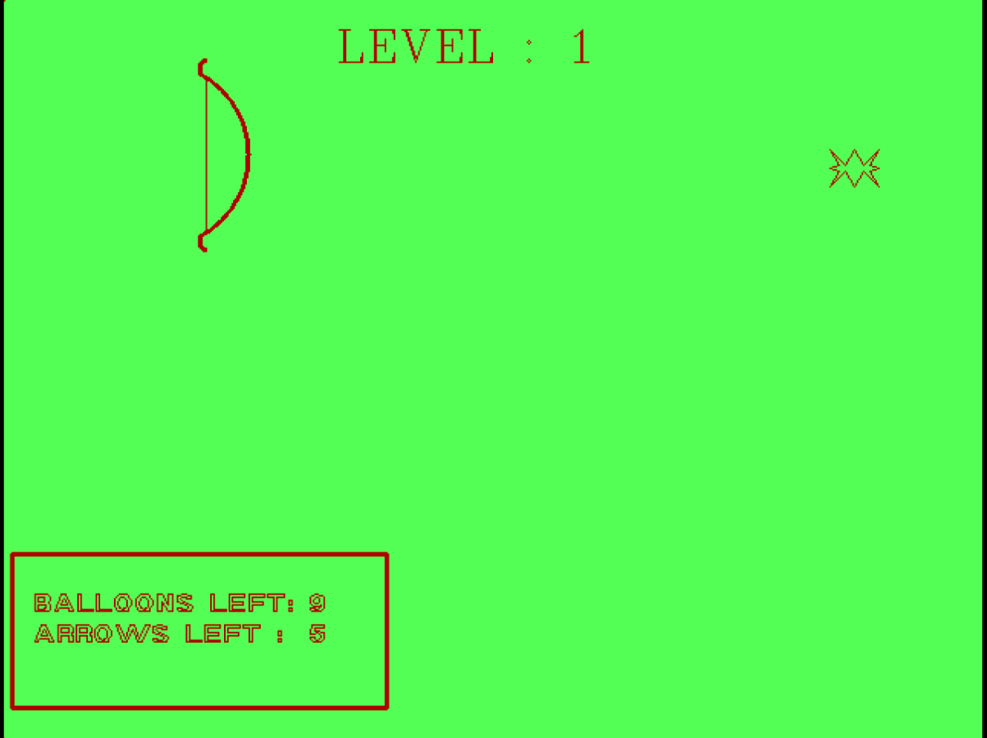

Fig 2: The screenshot is the gaming screen of the project. The user has to play game in this window.

**7.0 Skill Developed/ learning outcomes of this Micro-Project**

Various skills got developed in us by doing this project. This skills are

1. Creating the graphics diagrams.
2. Creating a balloon shooting game.
3. Creating the C Graphics programs for various applications efficiently.
4. Debugging the errors.
5. Using the concept of C Graphics.
6. Efficient communication skills.

This were skills developed by us during the project.

Learning’s were about the errors. The errors minor but it effects whole program. Some errors are difficult to debug. So, the code should be properly typed with proper syntax to avoid errors. We understood that, we need to improve our Debugging skills. We are lacking in some amount in it.

**8.0 Conclusion**

We successfully completed the project. We completed the project code and created the balloon shooting game. We learnt about the gaming applications of computer graphics. This balloon shooting game will be a different attraction for children.

**Submitted By:**

1.Patil Pratik Kumar 856

2.Chavan Shubham Sanjay 858

3.Surve Prathamesh Sanjay 859

4.Patil Vinayak Ramchandra 860

5.Yedage Bajarang Nau 806

**Miss. Paymal V.S.**

**Subject Teacher**